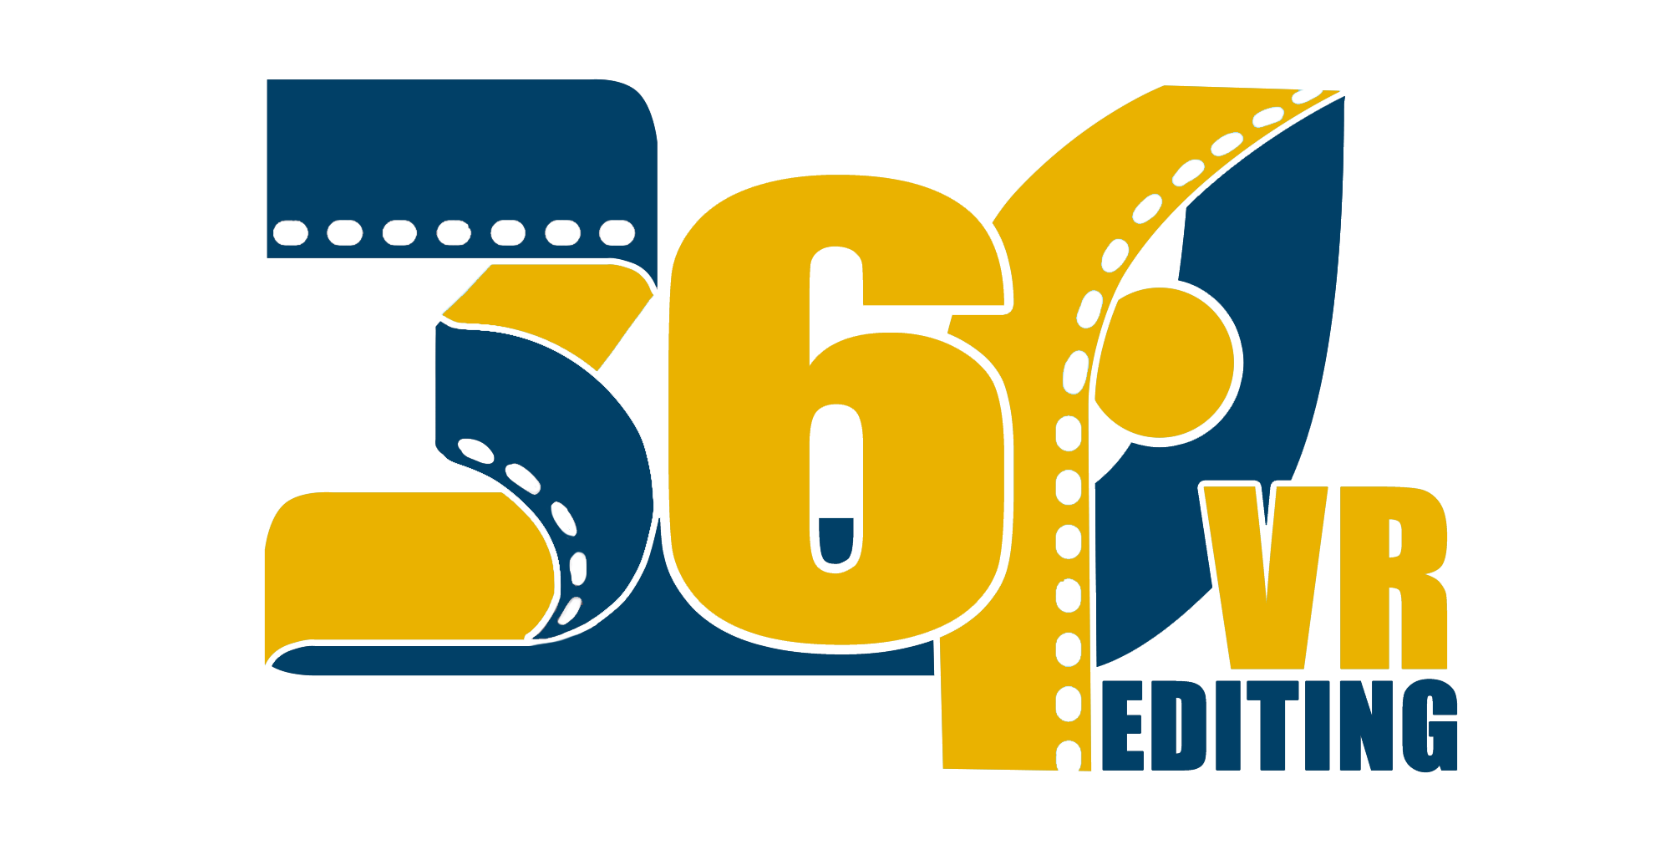
360$°$ Video Editing

STUDENTS
Lorella Matathia
Daniel Weisberg Mitelman

SUPERVISORS
Boaz Sterenfeld
Yaron Honen

Table of Content

Abstract 3
Introduction 4
Develop Environment 5
Application Overview 6
Development Process 7
Manual 9
Sight for the Future 16
Appendix 17

Abstract

As part of our B. Sc. in Computers Science, we were curious about the Virtual Reality world. While we were thinking about a theme for our final project, we found out that the 360 video editing is done, nowadays, with 2D screens. It means that major part of the 360 experience is “lost” while editing videos on flat screens.

Although the project can’t supply the needed tools for editors, we tried to create an environment that would show the advantages of VR. We hope that this project would be a start for next generation of professional video editors.

Furthermore, we would like to thank to the GIP & CGGC staff, and especially to Boaz Sterenfeld and Yaron Honen.

Introduction

360 Video Editing is a unique VR tool that gives you an option to edit a video, without losing the special experience. With the controllers, you can interact with the editor. You are able to delete frames, show specific frames and export the edited video.

The main functions that the editor provides:
- Displaying a video on sphere
- Dividing the video into sub-frames
- Displaying sub-frames
- Splitting video
- Showing effects
- Exporting final video

Develop Environment

Unity
A cross-platform game engine that can be used to create both three-dimensional and two-dimensional games, as well as simulations for desktops and laptops, home consoles, smart televisions, and mobile devices. Unity is scripted with C# in Visual Studio.

FFmpeg
FFmpeg is the leading multimedia framework.
It is able decode, encode, transcode, mux, demux, stream, filter and play pretty much anything that humans and machines have created. It supports the most obscure ancient formats up to the cutting edge.
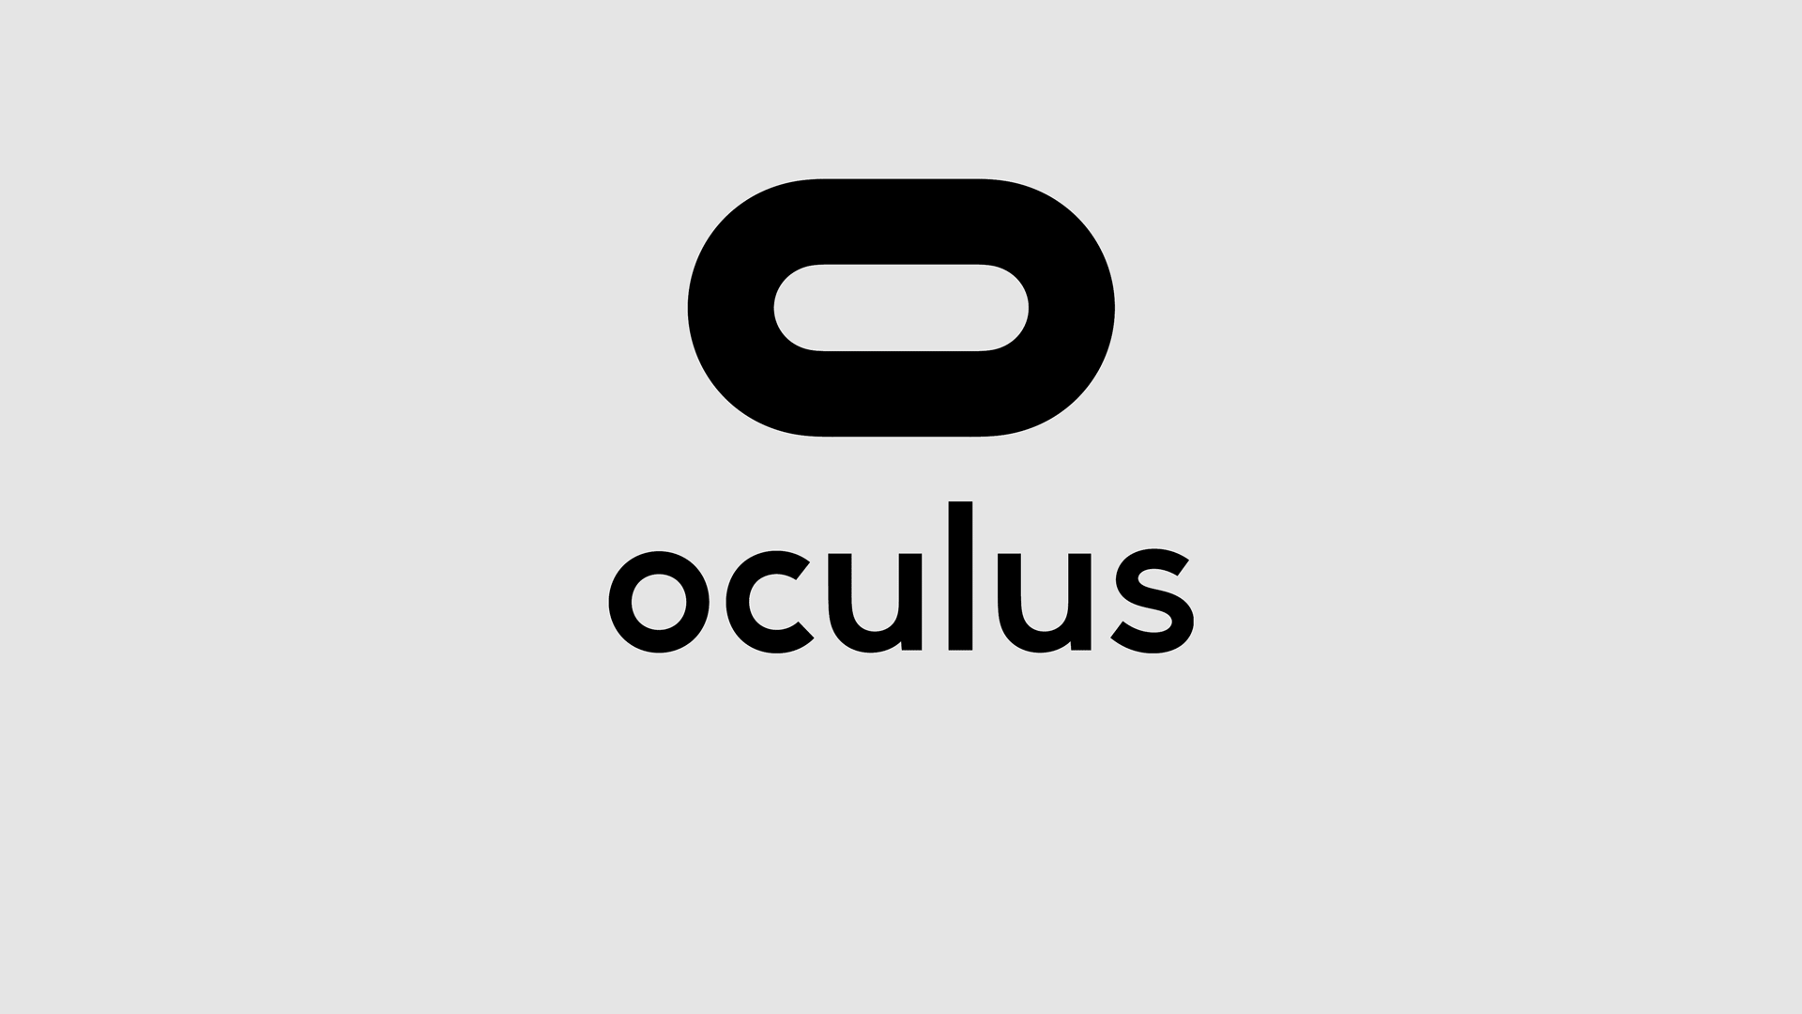
Required Equipment:
Oculus Headset: The Oculus Headset is a virtual reality headset. The headset uses tracking technology, allowing the user to move in 3D space and use motion-tracked controllers to interact with the environment.
Oculus Controllers: Each controller has inputs. The only buttons that are used are the grip and the joystick.

Application Overview

This chapter is a summarized manual. The complete manual is one of the next chapters.
The application starts in main menu scene. This scene contains three different videos that can be edited with our application. At any time, you can get back from each scene to the main menu.
In the scene, you get into the video. The video will be played automatically. There are four different UI buttons:
 | Play & Pause buttons  Clicking on this button will change it to the other one and will play or will pause the video.
 | Save button  The edited video will be saved to the folder: C:\UnityOutput
 | Edit button  Clicking on tis button will show 24 frames that will allow you cutting frames, see specific frames or jump to the relevant second of the frame. Clicking again will hide these frames.
 | Effects button  Opens an effect menu that allows you adding nine different effects.
 | Specific Effect button  Choosing an effect that gives you a different experience of the video.
 | Volume button  The button lets the user muting and unmuting the video sound. The volume bar can give an option to change the volume.
 | Return button  Get back to the main menu.

Development Process

When we came across with the idea of having a final project in the CGGC & GIP laboratory, we thought what kind of project might be special and a bit different. We decided that we will focus on video editing. Because we are using a 3D environment, we would edit 360 videos. The Unity program was our tool in this VR world. With unity, we created a "mini studio" that we could show frames, delete them, play just parts of them and export the edited video.

In the beginning, our idea was to show the frames in a special way: a ring that will be around the editor. This format was like a timeline that is in front of the editor, with some unique editing options: deleting and playing specific parts of the video.

Later on, we decided that we need to create a new video that will be played, instead of the current video, after cutting some frames. This will allow to the editor to see his work until now. Creating a new video can be a project by itself, but with some help from our supervisor, Boaz Sterenfeld, we found out that the application FFmpeg is capable of editing huge videos just with the command line (cmd). We decided that we need to cut the video to 24 frames, and in every cut, there is a smaller video that will be made by concatenating the relevant videos. This can be made pretty easily with FFmpeg.

After editing the video, we wanted to let the editor to save its work. We searched for simple Windows commands for the command line that will let us saving the final video. Because we already made with FFmpeg the new video, we just had to copy it to a simple directory and to rename it to a name that will be indicative for the user needs. We opened from C# script a cmd window (as administrators) and copied it, and later on changed its name to the current date and time. This made it unique and let the option to save as many videos the editor wants.

When we finished the project, we wanted to add a special menu page. We purchased an asset from Unity Store (don't worry, it's just 4$...) and made some changes that it will fit our needs.
Before we finished the project, we added video effects to the editor. At first, we found out that there is an FFmpeg plugin called FREI0R. We tried for about three days to download and install it, but there were too many bugs and we decided to stop trying. We found out that there is component called Camera Filter Pack 3.x for Unity 5.x. This let us working with cool effects that were added to the Oculus headset camera. The only problem is that you can see the effects, but you can't save them to the final video.
To sum up, this project has lots of knowledge that we have had to gain. Bringing up video editing with command line scripts that come together with video effects – that is lots of work! But, wf feel happy and proud with our work.

Manual

This chapter will explain, step by step, how to use our application:

Welcome!  This is the main menu. Here you can choose which video you would like to edit. |  | 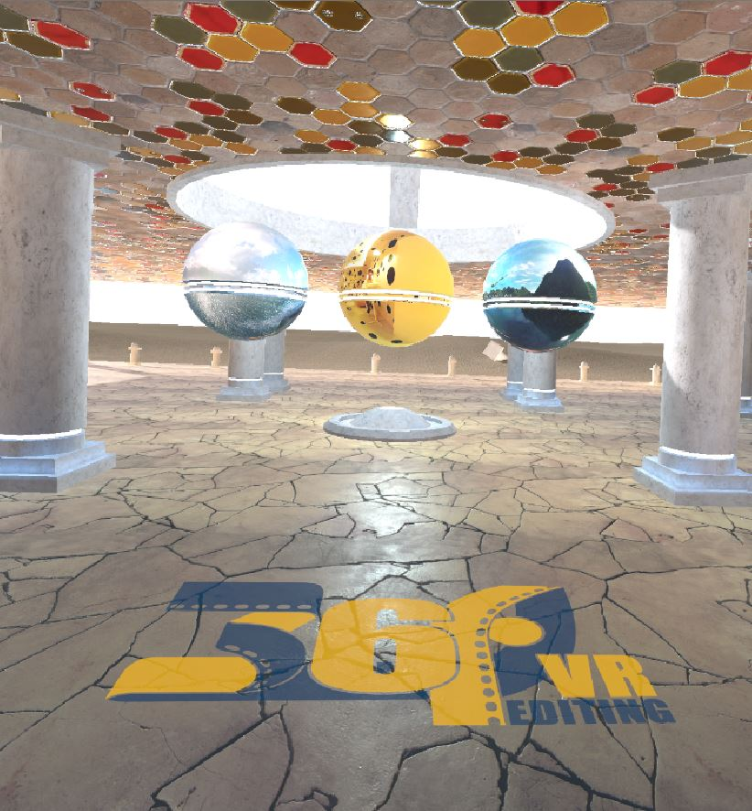
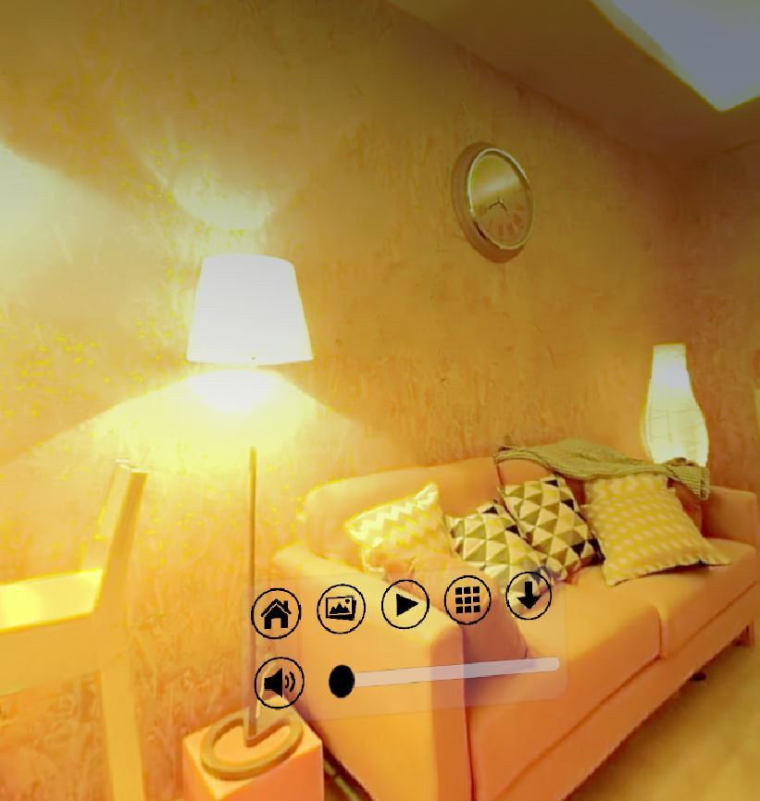 |  | Start here  This is the opening of editing a video. The video will start playing immediately.
Toolbar  toolbar in front of you:  - Pause/Play: runs or stops the video  - Edit: shows or hides the frames.  - Save: saves the edited video to specific directory.  - Effects: shows effect menu.  - Return: get back to the main menu.  - Sound: changing the sound and muting or unmuting, |  |  | 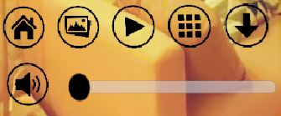
 |  | Play button  Starts the video. After clicking on it, this button changes to Pause.
Pause button  Stops the video from running. After clicking on it, the button changes to Play. |  |  | 
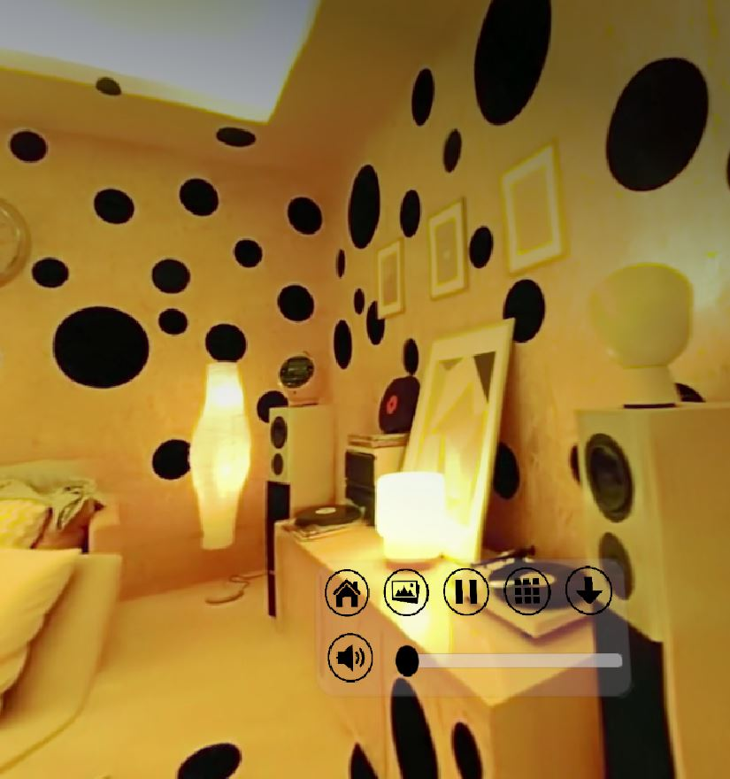 |  |  | Played video  This is the video after clicking on the play video (the video starts as a paused video).
Edit Mode button  Clicking on the picture logo will bring up 24 frames that represent 1/24 seconds from the whole video (in this specific case, the length of the video is 1:12 minutes, so every part has 3 seconds).  Clicking again on the button will take down all of the frames. |  |  | 
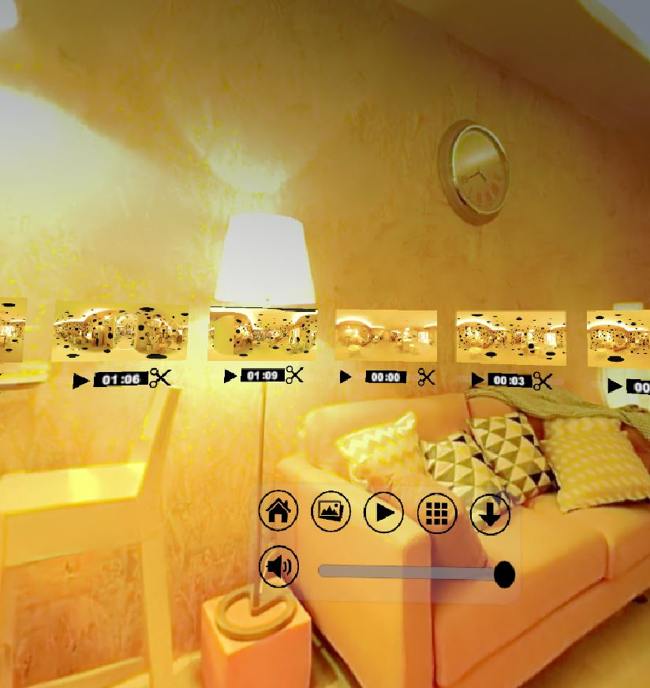 |  | Edit Mode  Every frame has four different UI:  Time: the second that starts the frame. When playing the video, the time will start running until the specific part ends.  Frame: After clicking on the frame, the video will move to the specific second of the frame.  Play button: Brings closer the frame and plays it.  Scissors button: Start cutting frames from this specific frame.
Edit Mode  Since we are in Virtual Reality environment, we can turn around and see all of the frames around us. Pay attention to the fact that you can use the UI that was shown before for a specific frame with every frame. |  |  | 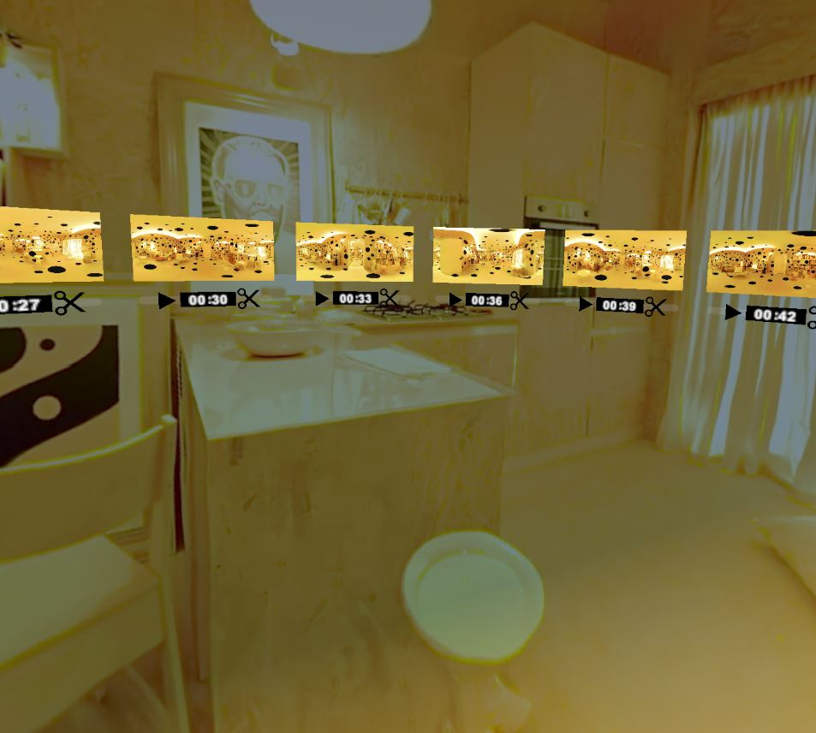
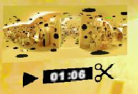 |  | Go to a specific frame  When you click on the frame itself, the video in the background changes its time to the relevant frame.
Play specific frame  By clicking on Play button that is attached to a specific frame, you can see the 1/24 part of its video. When it ends, it will get back to its place. |  |  | 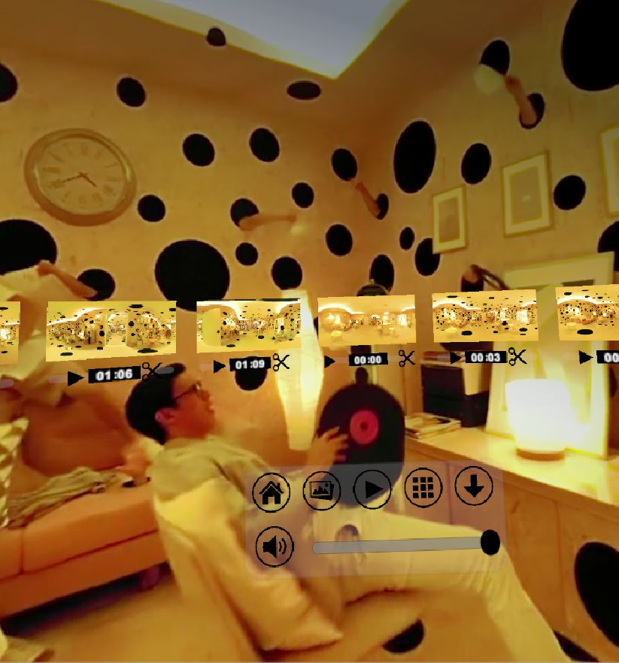
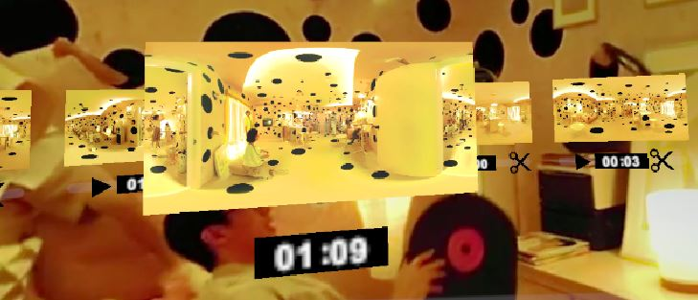 | Play specific frame  The shown frame is bigger than the rest frames.
Cut Frames  When you click on the scissors of the frame, they will have white outline around it. Now you need to choose one more frame that you’d like to cut. |  |  | 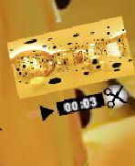
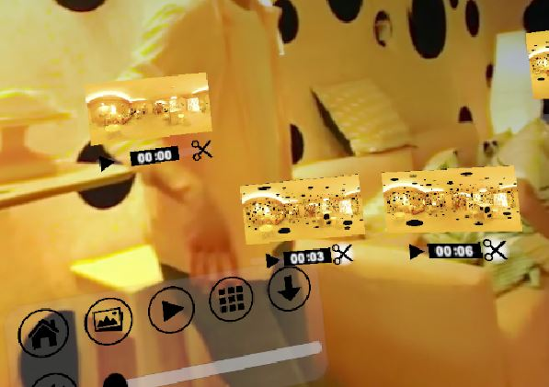 |  | Cut Frames  After choosing the second frame that will be cut, the chosen frames will fall and won’t be seen ever again.  Please pay attention to the following cutting rules:  - Cut can’t be done backwards: if you chose frame number x, you can choose a frame that is equal or greater than it.  Cut can’t cross zero: for example, if you choose frame number 20, you won’t be allowed to choose frame 2.
Cut Frames  After cutting the frames, a gap will remain from the last frame to the first frame. The video that is played in the background is changed too.  If you choose to save the current video, the edited video will be saved. |  |  | 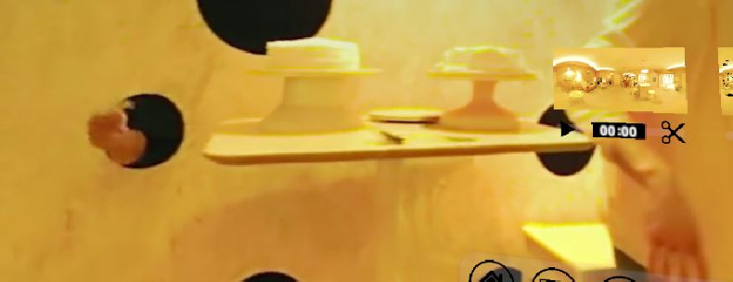
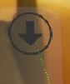 |  | Save button  When clicking on the Save button, the edited version will be saved to a specific folder.
Save Video  A message showing the path will be shown. |  | 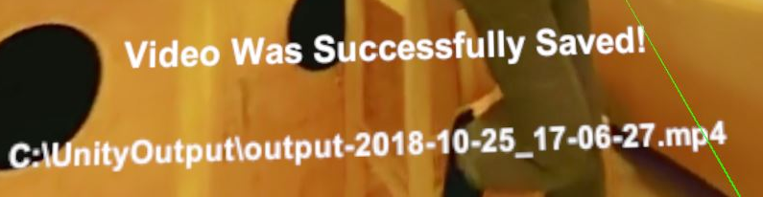
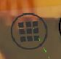 |  | Effects button  The effects button will open a menu with nine different effects that will change the video's appearance. The effects won't be saved on the edited video.
Effects menu  When clicking on one of the effects, the video will be changed with its current effect. You can combine some effects together. |  | 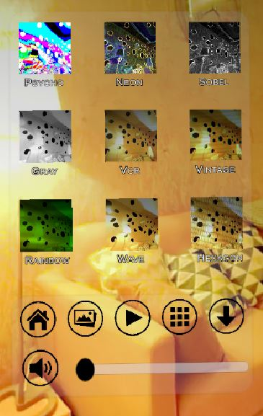
 |  | Volume button  The volume is muted, clicking on the button will unmute it.
Volume button  Unmuting the video. |  | 
 |  | Volume bar  The volume can be changed by moving the bar. The sound will unmuted automatically (if it was muted).
Return button  When you click on this button, you get back to the main menu. |  |  | 

Sight for the Future

Unfortunately, this project has come to an end, and our work on it has to stop. If we could suggest some extensions and additions to the continuous project, we would recommend to add the following options:
- Split into more than 24 frames, so we would be able to select carefully the wanted parts.
- Loading unlimited number of videos.
- Combining two or more videos into one final video.
- Adding sound editing, as part of the video editing.
- Saving the effects on the video itself.

If anyone takes this project and continues it, we will be happy to hear!

Appendix

We would like to show the chosen effects of one of the videos:
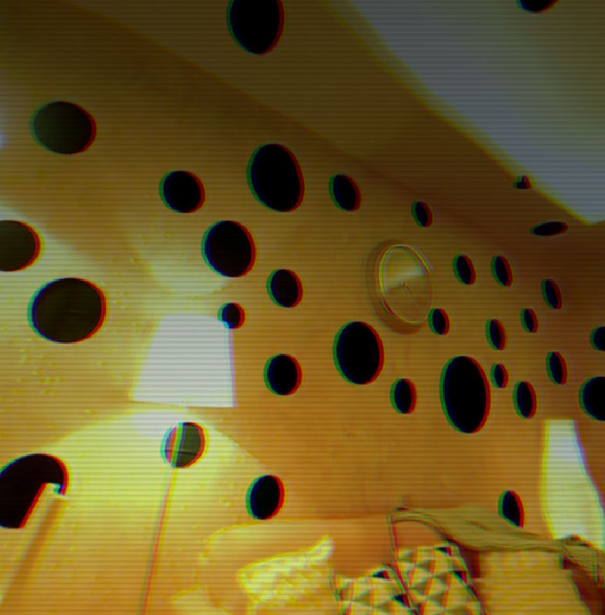 | 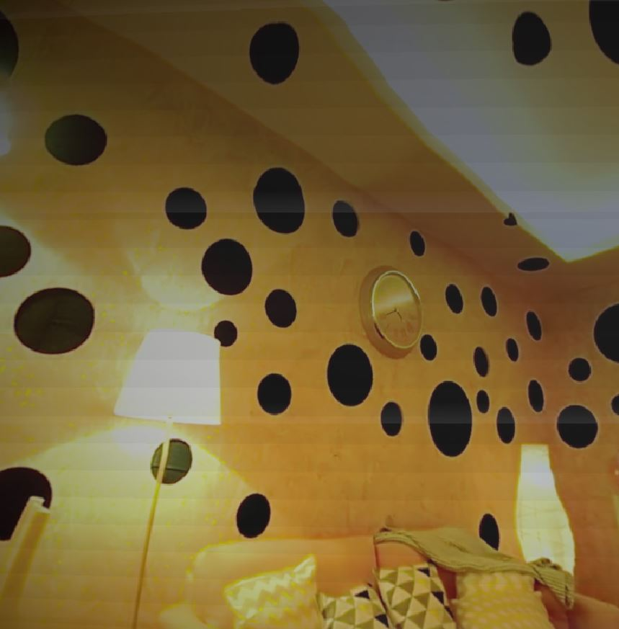 | 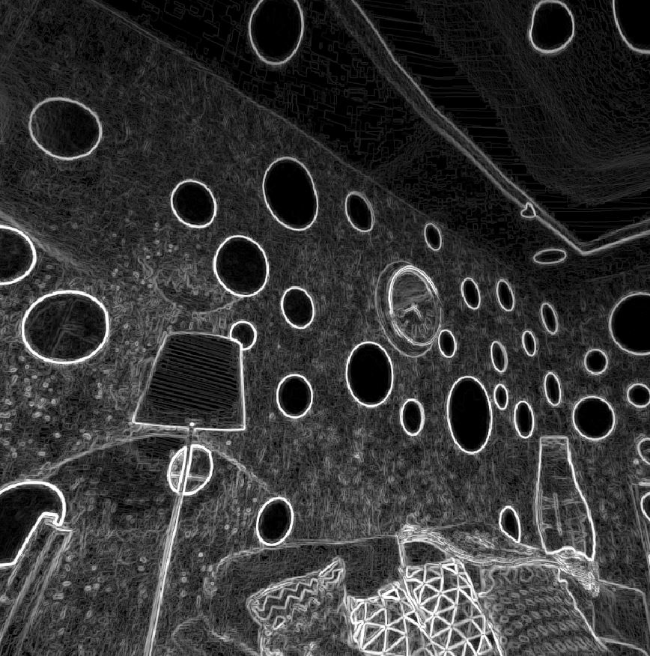
Vintage | VCR | Sobel
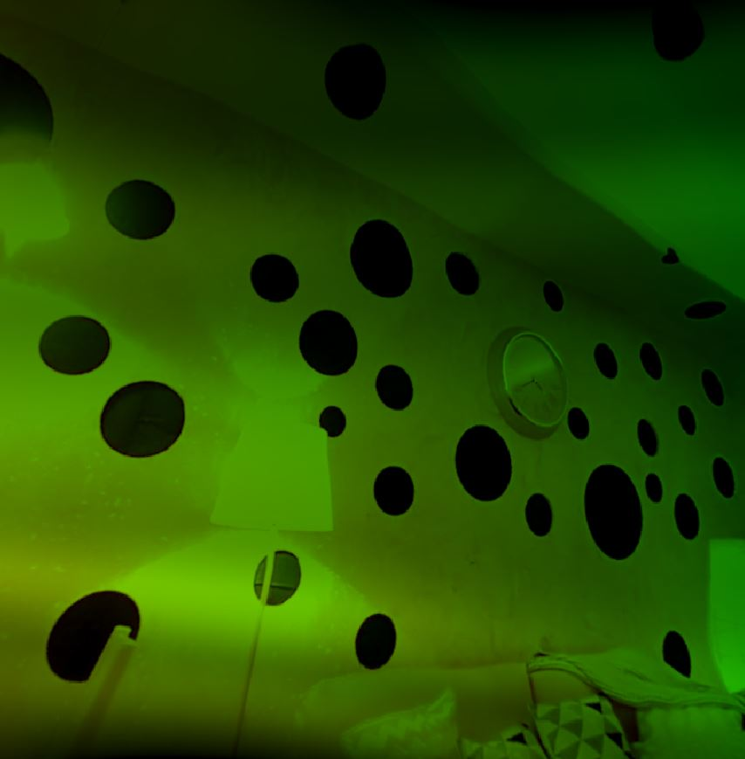 | 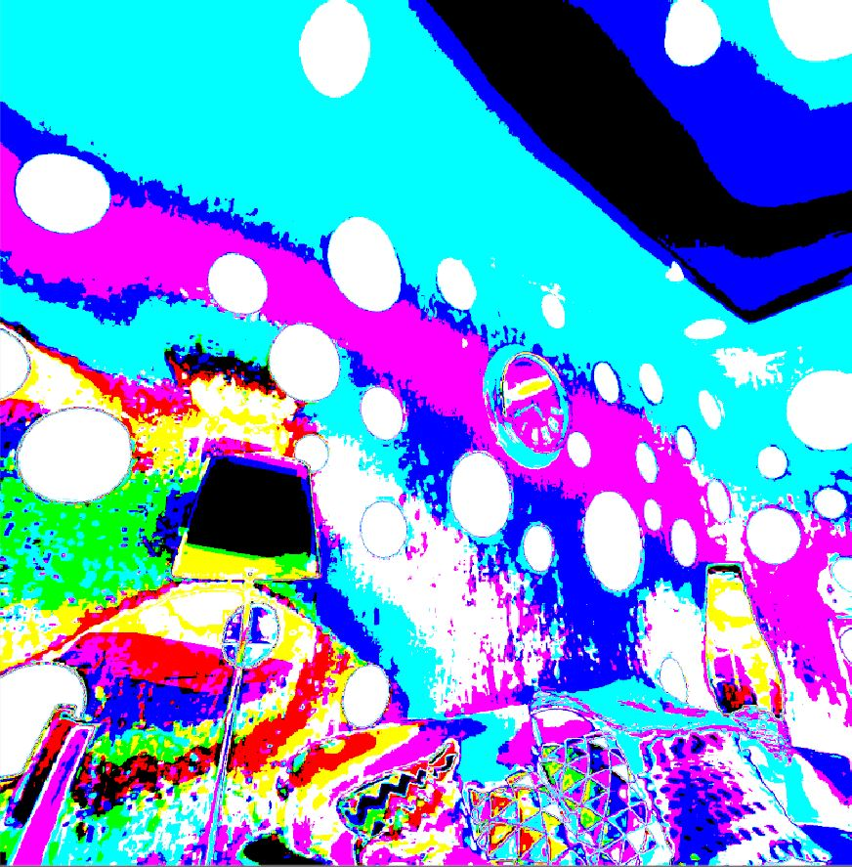 | 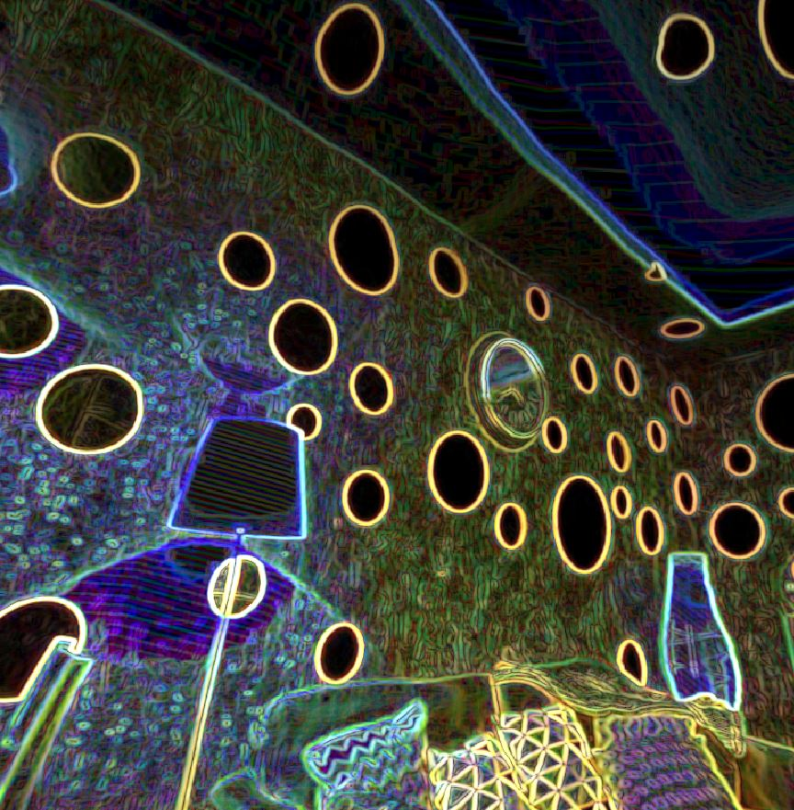
Rainbow | Psycho | Neon
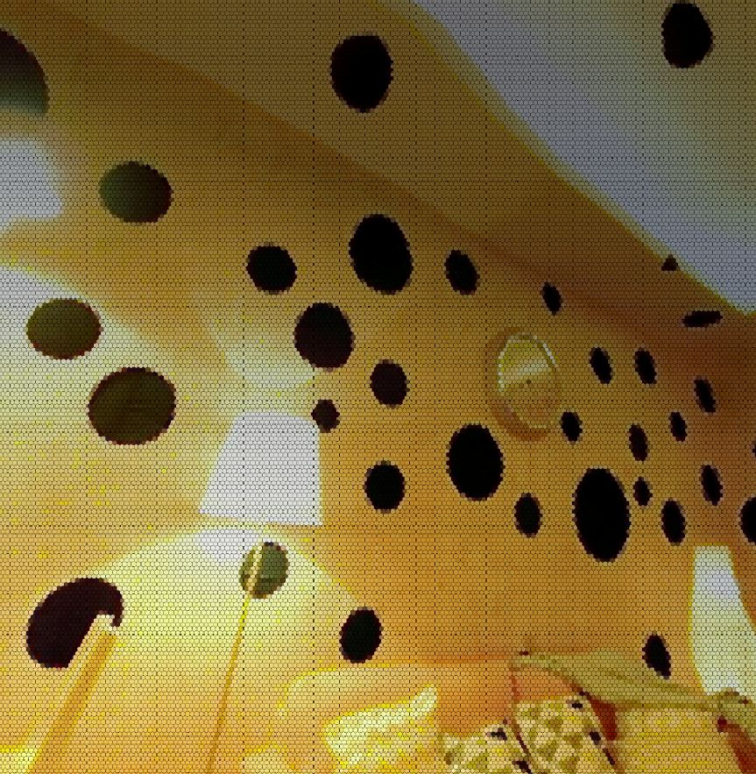 | 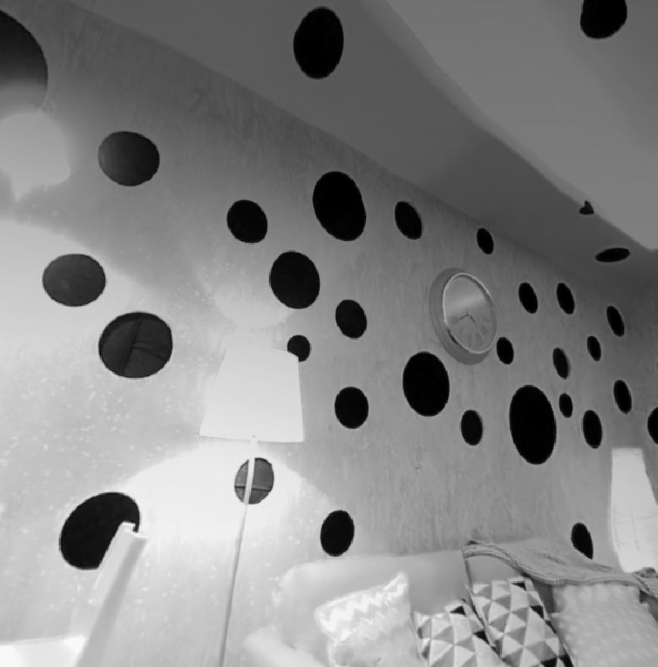 | 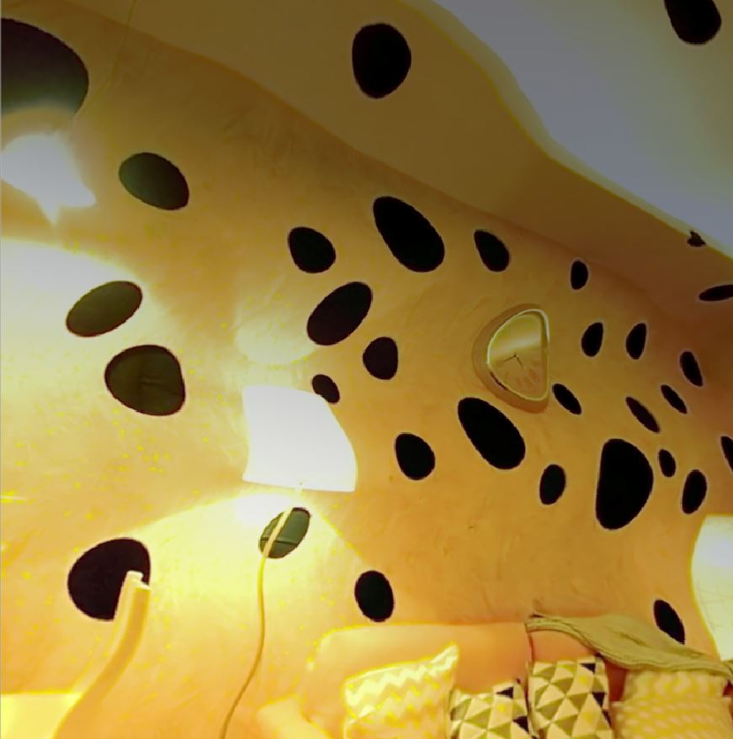
Hexagons | Grey | Waves

en.wikipedia.org/wiki/Unity_(game_engine)
ffmpeg.org

